Mrs. Morgan’s  Student  News |  | 

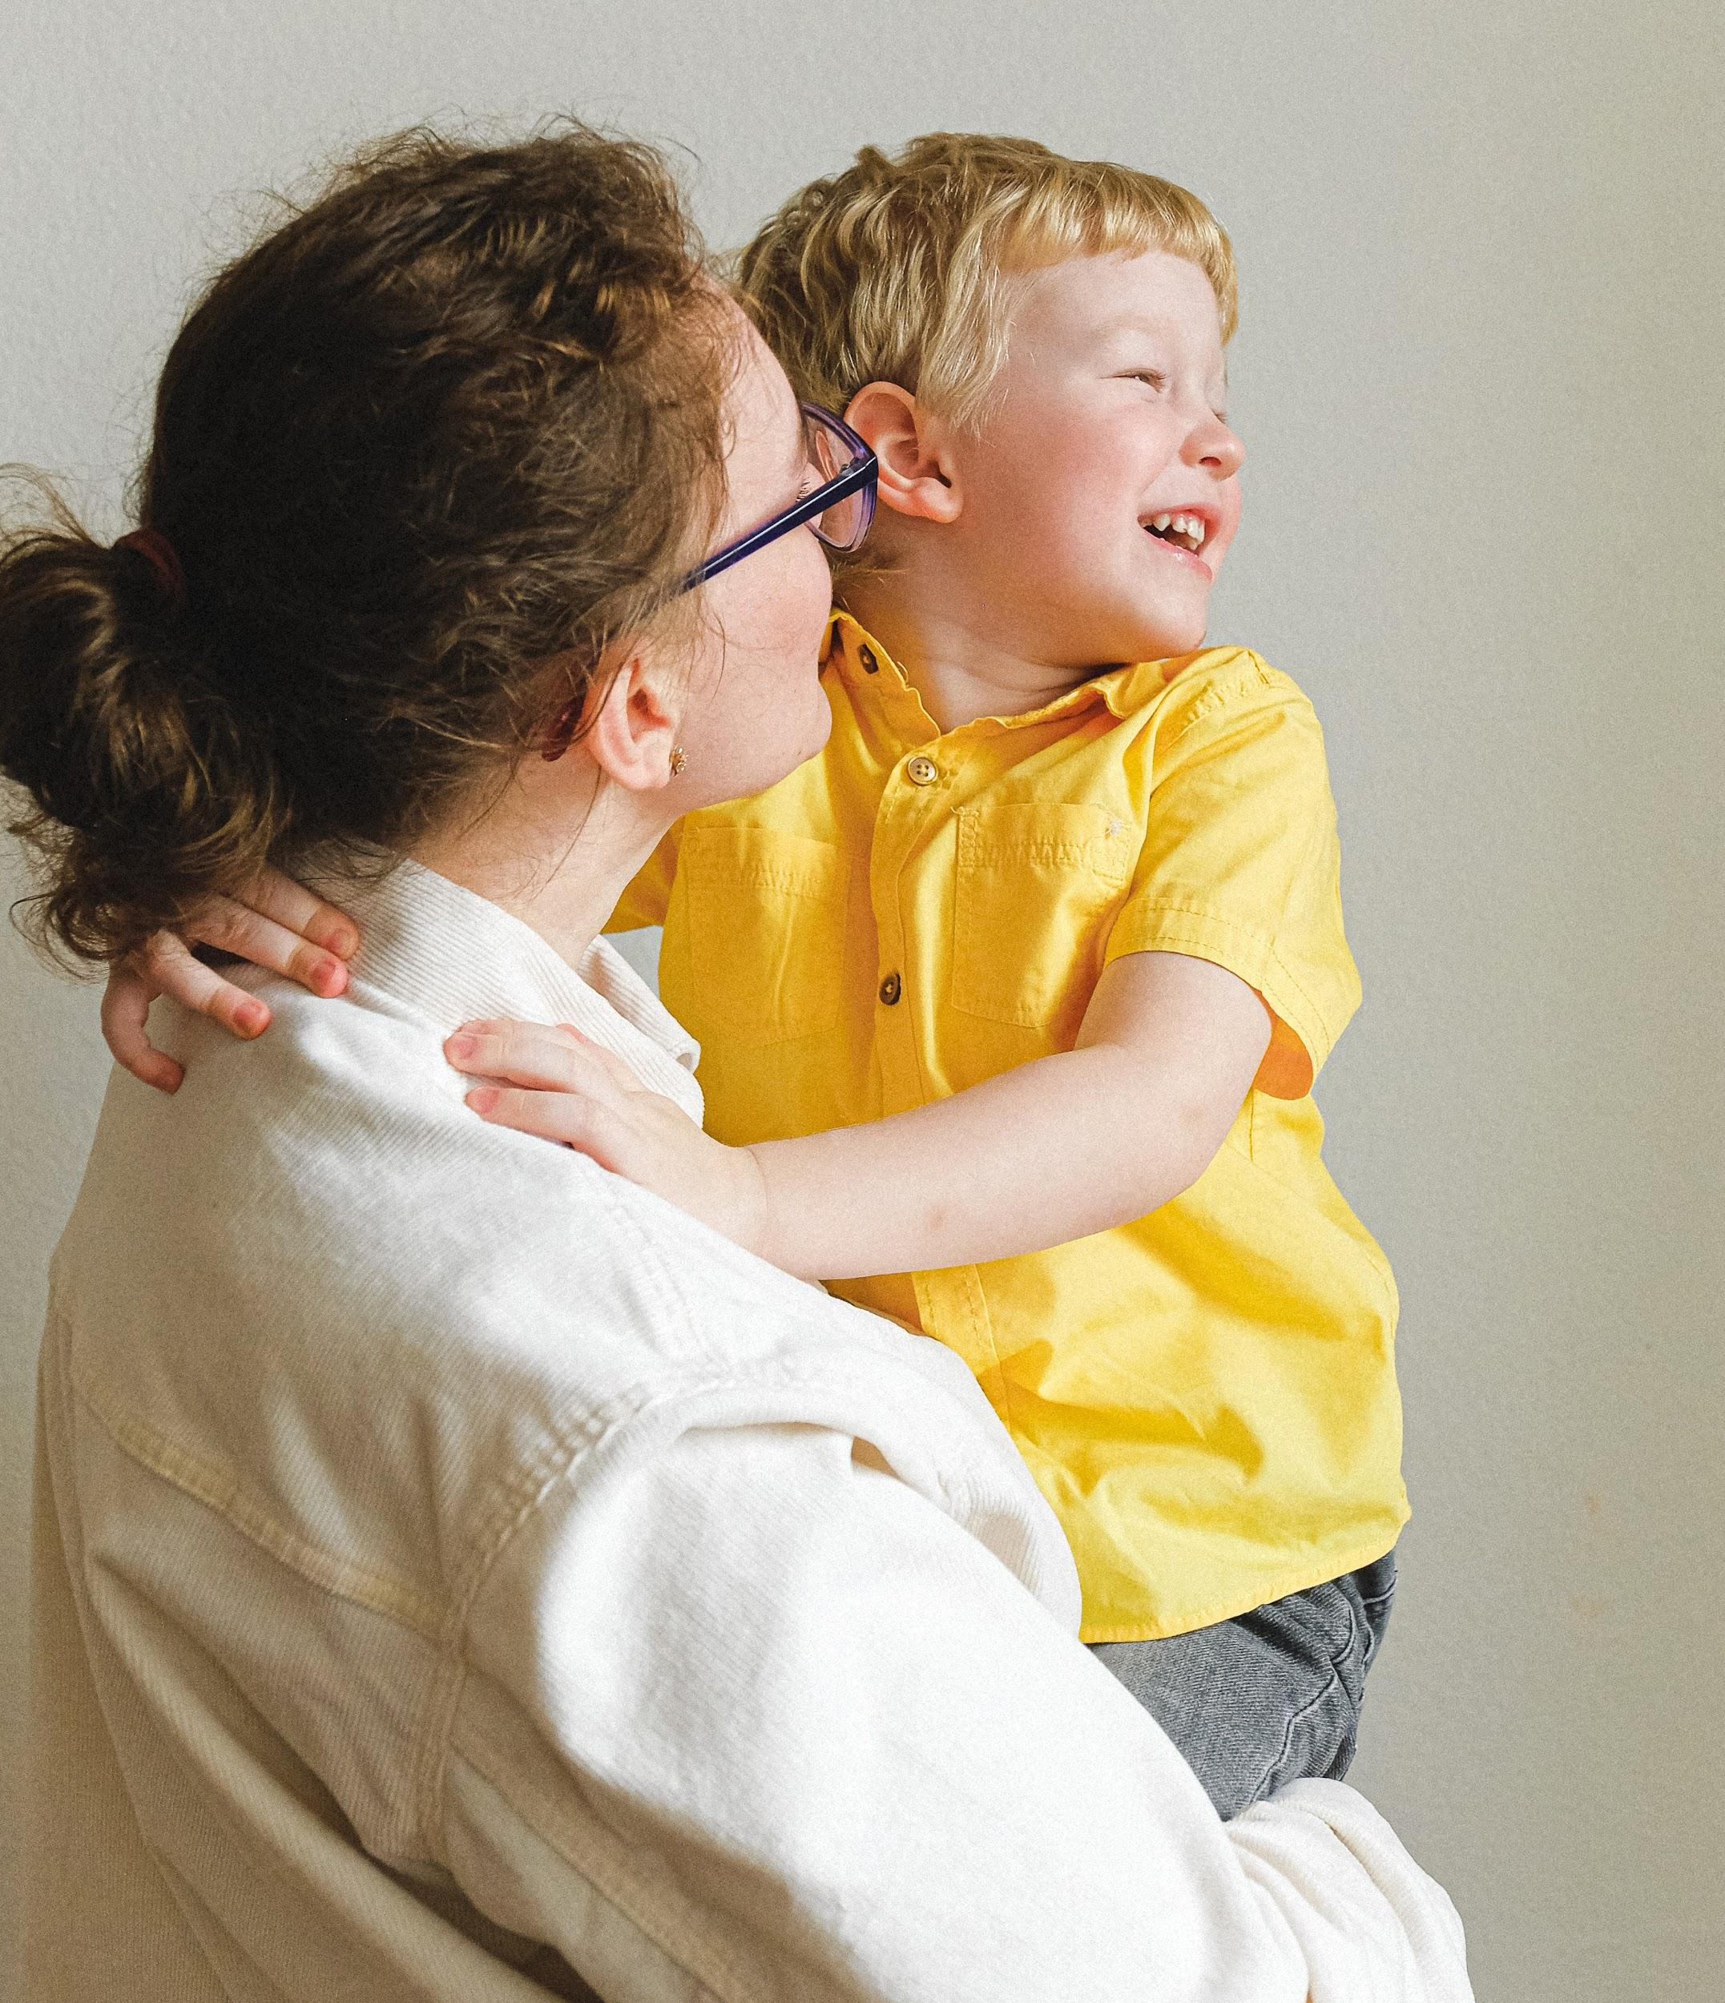 | News for the week of: March7, 2026  Reading: 20 minutes per night  Multiplication facts: practice 5 minutes each night. We are currently taking timed multiplication tests.(X 5 this week)  Spelling words (tiniest, hobbies, copied, countries, pitied, easier, laziest, families, spied, happiest, ladies, friendlier, studied, busier, breezier, prettiest, noisier, butterflies, funniest)  Vocabulary: (waste, mechanical, inspector, calculated, dispute, insert, superior, centuries, average, progress)
WI
 | Content Standards for the Week:  READING: The Fun They Had  (SKILLS): articles/adjectives/adverbs  MATH: Multiplying Fractions
 | Other Communication:  March  (11) Spirit Day  (12) DOJO PARTY (bring a single snack/drink)  (13) Faith Families/Shadow Stations @2:30  (16-20) Spring Break  (27) Virtue Awards

